**SQL**

**Case study – 1**

**Task Duration:4 Hours Marks :10**

**Problem**

Create a student management system to handle student Enrolments in courses, track course details, and manage student information.

**Description:**

The student management system handles student enrolments, course tracking, and student information. It includes tables for students, courses, and enrolments. Students can enrol in multiple courses, each with specific details. The system tracks course credits, student data, and enrolment dates, facilitating efficient management and analysis of academic data.

**Modules steps**

**Step 1:** To create student management system using SQL Server with three tables: Courses, Students, and Enrolments.

**Course table**

CREATE TABLE Courses ( CourseID INT PRIMARY KEY IDENTITY, CourseName NVARCHAR(100) NOT NULL, Credits INT NOT NULL );

**Student table**

CREATE TABLE Students ( StudentID INT PRIMARY KEY IDENTITY,FirstName NVARCHAR(50) NOT NULL,LastName NVARCHAR(50) NOT NULL, DateOfBirth DATE, EnrollmentDate DATE);

**Enrollments Table**

CREATE TABLE Enrollments (EnrollmentID INT PRIMARY KEY IDENTITY,StudentID INT FOREIGN KEY REFERENCES Students(StudentID),CourseID INT FOREIGN KEY REFERENCES Courses(CourseID),EnrollmentDate DATE);

**Step 2:** How can you list all the students in the system**?**

**Step 3:** How can you find all students enrolled in a particular course?

**Step 4:** How can you list each course and the number of students enrolled in it?

**Step 5:** How can you find students who are enrolled in more than one course?

**Step 6:** How can you retrieve the enrolment details, including the names of students, for a specific course?

Step 7: How can you find students enrolled in both "Introduction to SQL" and "Web Development"?

**Step 8**: How can you find the total number of enrolments in the system?

Model output:

Step 2

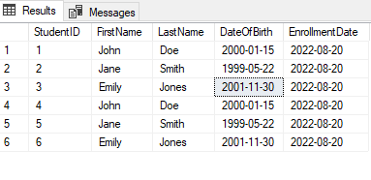

Step 3

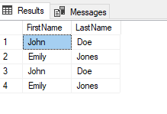

Step 4

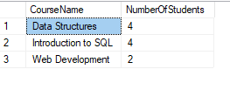

Step 5

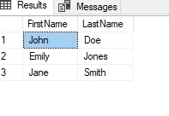

Step 6



Step 7

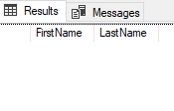

Step 8

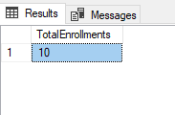

------------------Best Of Luck----------------------